Pastor Jay’s Jottings – April 2025

Grace and peace to you from Jesus Christ our Risen Savior and Lord!

I love this time of year. Truly. While Fall is my favorite time of year, Spring is a really close second. Of course, the awesome pastoral “churchy” reason would be that Easter is in the spring, and it comes with new life after death, as the world begins to come out of her hibernation and life begins to return. So many great analogies and images.

But it is also baseball season. Today, (March 27) as I write this, it is “opening day” in baseball. And what I love about opening day is that every team has an optimism for the season. No wins or losses, just an anticipation for a new season with a new hope and opening day is more about the joy of baseball returning than the expectations of a successful season.

But the players have practiced and put in the time, so they are waiting for a reward. Their reward comes in the form of contracts and batting averages and RBI and wins and losses, but they practice to get better and better and the training they put in, is for the future results. As followers of Christ, we too have practicing to do. I’ve enjoyed walking through these “spiritual practices” during lent. We have been walking through practicing scripture, practicing prayer, practicing solitude and practicing generosity, and the big one, practicing sabbath.

These practices do help us abide with God and connect us more deeply with Jesus, and that is a huge benefit for our life today, but they are also preparing us for the future. The apostle Paul wrote to Timothy, in **1 Timothy 4:**

***7****Have nothing to do with irreverent, silly myths. Rather****train yourself for godliness****;****8****for while bodily training is of some value, godliness is of value in every way, as it holds promise for the present life and also for the life to come.*

Spiritual practices keep us connected to God and help align our lives with Jesus and that is important here on earth, but also as it is in heaven. We are called to be a holy people. Set apart for the purposes of God, and training for that game to be played on that field is more important than anything else we do. (Yes, more important) Because as we continue to train, we will ultimately receive the greatest gift, the joy of living forever with God.

There is an image out there that reminds us of why we train, and it is connected to baseball.

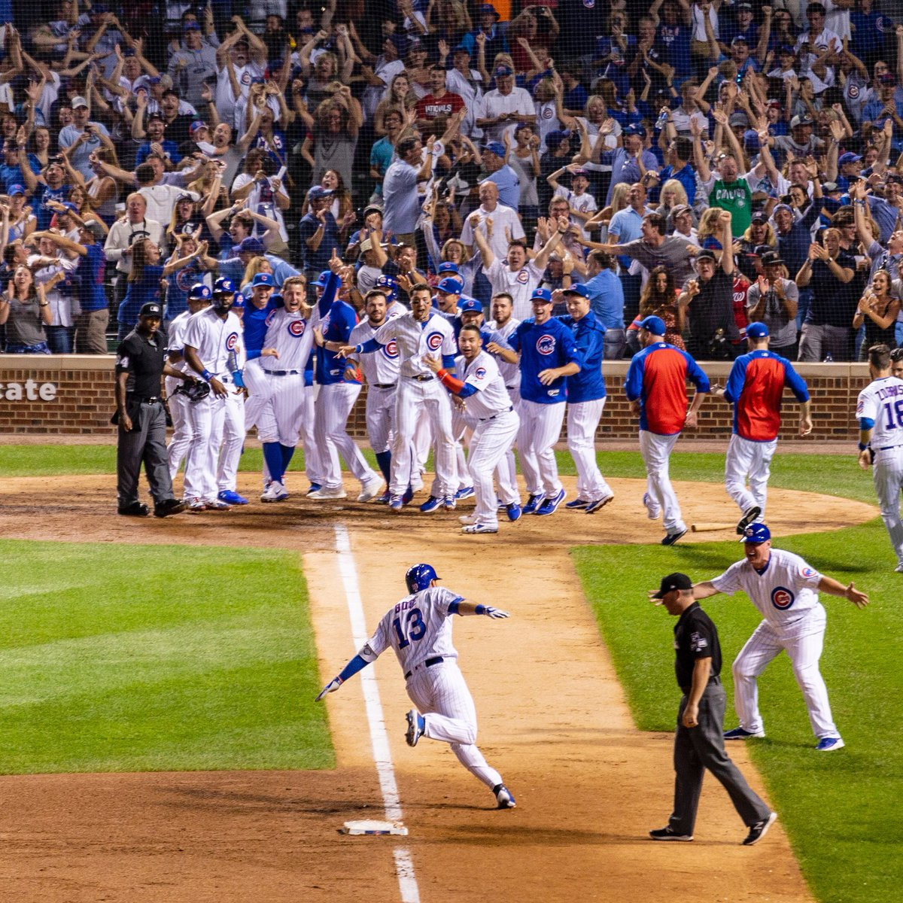

I first came across this image in an article. A gentleman has been collecting images of “walkoff” homeruns because a “walkoff” ends the game. And when the game ends there’s a big celebration at home plate, and this is such an amazing image of heaven. Each one of us rounding third and being welcomed by all of those who have been a part of the team in one amazing celebration! This is one of the best images I could ever imagine. This is what the training is for. This is what our call to be Holy is about. This is heaven. (I also think we will play baseball in heaven because it’s the best sport out there.)

Anyway, thank you for what you do for the kingdom. It matters. You matter. And as we come together as a team for the Kingdom of God, know that each of you has a role to play. But please practice. Please stay in communion with one another and with Jesus. Today’s world needs our faith and witness more than ever. I look forward to spending Holy Week with you at FELC, and I can’t wait to proclaim those amazing words…. “Christ has Risen….”

God Loves You and So Do I,

Pastor Jay